

Software Engineering Department

Braude College of Engineering

Capstone Project Phase A

**Deep Learning Model for Automated Detection of Meniscus Tears in Knee MRI Images**

**24-1-R-22**

**Supervisor:**

Miri Weiss Cohen

**Students:**

Neta Amzalag, [Neta.Amzalag@e.braude.ac.il](mailto:Neta.Amzalag@e.braude.ac.il)

Vital Marciano, [Vital.Marciano@e.braude.ac.il](mailto:Vital.Marciano@e.braude.ac.il)

Table of Contents

Introduction 3

Meniscus anatomical structure 3

Related Work 5

Background 10

Expected Achievements 12

Research 13

CNN Architecture Research 13

Hyper Parameters 16

Product 17

Sequence diagram 17

GUI 17

Evaluation/Verification Plan 19

References 20

# Introduction

Meniscal tears, a disruption in the meniscus cartilage of the knee joint, can significantly impair knee function and necessitate surgical intervention to repair or remove the damaged tissue ‎[1]. The meniscus plays a crucial role in distributing weight and absorbing shock between the shinbone (tibia) and thighbone (femur), ensuring smooth knee movement, it is one of the most frequently injured ligaments, due to its anatomical structure and function ‎[10]. Long-term consequences of meniscal removal can lead to accelerated joint degeneration and reduced mobility ‎[1], Early diagnosis and appropriate treatment are essential to prevent further damage and optimize patient outcomes it mostly common with athletes and active population ‎[10].

Accurate classification of meniscal tears is critical for determining the prognosis and guiding surgical decisions. Repair procedures, where the torn edges are sutured together, are suitable for certain tear types and locations. Meniscectomy, the removal of the damaged meniscus, is performed when tears cannot be repaired. Additionally, meniscus transplantation offers an alternative option for severe cases.

Currently, diagnosis of meniscal tears primarily relies on MRI scans interpreted by radiologists. However, inconsistencies in meniscal tear classification can hinder effective treatment planning and healing operation chances ‎[2]. Machine learning techniques, particularly deep learning algorithms, have demonstrated remarkable potential in medical image analysis tasks, including meniscal tear detection and classification.

Our research aims to address the challenges of inconsistent meniscal tear classification and provide a reliable tool for radiologists and clinicians to make informed treatment decisions. By facilitating early diagnosis and appropriate treatment, we can minimize patient pain, disability, and healthcare costs. For example, Shin et. al suggest a model that produces good results in detecting meniscus tears. However, its performance in classifying types of tears is slightly lower, achieving an accuracy of 72.23% for horizontal tears, and 72.48% for radial tears‎[5]**.** Our goal is to design an efficient DenseNet -based model for classifying types of meniscus tears

## Meniscus anatomical structure

Menisci are fibrocartilaginous structures located on the medial and lateral side of the knee joint. The medial menisci is C-shaped, while the lateral menisci is almost an O-shaped and smaller in size compared to the medial one‎[3] ,(fig. 1)‎[4]. The circumference of each crescent is thick, convex and attached to the joint capsule, whereas the inner edges are thin, concave and freely movable. Both horns of the menisci are attached to the tibia bone. Superiorly, they are concave to enhance the congruence of the joint surfaces [3].‎

Menisci can be divided into three zones, according to their blood supply. Red-red zone represents the vascular peripheral region with a rich blood supply. The inner region, known as the white-white zone, lacks blood vessels and is avascular. The red-white intermediate zone resides between the red-red and white-white zones, (fig. 2). sharing characteristics of both. The potential for healing meniscal tears varies depending on the vascular region involved. Blood supply in the zone determines the likelihood of the tear healing ‎[3].

The menisci have several vital roles in the knee joint, as they perform few essential functions. They include load transmission, shock absorption, stability, nutrition, joint lubrication, and proprioception.

However, meniscal tears are the most common knee pathology with a mean annual incidence of 66 per 100000 people. These tears have the potential to affect their main functions and the natural knee mobility. Medial meniscus tears are more common than lateral meniscal tears due to their strong attachment to the deep medial collateral ligament and joint capsule.

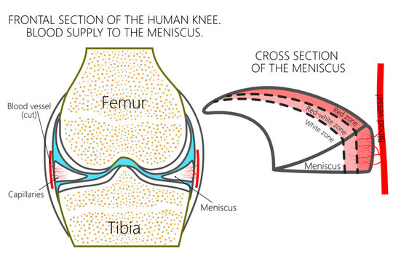

fig. 1 medial and lateral meniscus

fig. 2 zones of blood supply of the meniscus

In addition, the medial meniscus absorbs up to 50% of the impact within the medial compartment, making it susceptible to injury. Conversely, the lateral meniscus has greater mobility and is less firmly anchored to the lateral tibial plateau compared to the attachment of the medial meniscus.

Typically, meniscal tears are classified into groups, based on their anatomical appearance and location, (fig. 3). According to the ISAKOS classification, meniscus tears can be described based on the various tear patterns. The classification includes: vertical longitudinal, horizontal, radial, flap and complex tears. Meniscal tears can also be categorized as either partial or full-thickness.‎[3]

The location of the menisci and its shape with the different types of tears affects the selected treatment method, therefore a precise diagnosis method is crustal for effective healing process ‎[5].

There are several methods to identify meniscus tears including the McMurray Test, Apley’s Compression Test, and imaging methods. Magnetic resonance imaging (MRI) is the modality of choice for meniscal tear as it provides information for both diagnosis and surgery ‎[6] (fig. 3).

Due to its superior soft tissue contrast, MRI is highly accurate in detecting meniscal tears. Compared to arthroscopy, MRI shows 93% sensitivity and 88% specificity for medial tears, and 79% sensitivity and 96% specificity for lateral tears, making it a preferred diagnostic tool in contemporary practice in addition MRI is noninvasive tool comparing to arthroscopy ‎[7].

The diagnostic accuracy of MRI scans in identifying the presence and type of meniscal tears varies significantly between specialists in knee pathology and other medical practitioners ‎[5]. This discrepancy underscores the challenge in precisely locating and interpreting meniscus tears from MRI images. Developing a system to assist in the interpretation of knee MRI scans would greatly support clinicians in effectively managing patients suspected of meniscal tears.

Hence, the challenges that associated with the identification of meniscal tear and the leak of a system that detect a tear with high accuracy, we want to perform an automatic segmentation to identify meniscal tears in order to support doctors in the diagnosis process and even replace radiologists.



fig. 3 types of tear viewed in MRI

# Related Work

Magnetic Resonance Imagining (MRI) is one of the most commonly used diagnostic tools in neurology and neurosurgery for evaluating and predicting enduring impairments in patients with MS. Using this technique, intricate structures within the knee can be visualized without the use of ionizing radiation.

MRI images contrast depends on fluctuations in the signal intensity, where the intensity corresponds to grey-scale representations of tissues or fluids. Specifically, heightened signal intensity manifests as a white hue, intermediate signal intensity adopts a grey tone, while diminished signal intensity assumes a black hue. The extent of contrast can be partially controlled by adjustable parameters, allowing for the generation of images with varying levels of contrast, depending on the composition of the tissue ‎[8].

However, interpreting MRIs can be subjective and time-consuming. This review examines how convolutional neural networks (CNNs) offer a promising approach for automated and objective diagnosis of meniscus tears from MRI scans.

Xia et al. (2022)‎[5] implemented a two-stage deep learning approach for meniscus tear diagnosis. The first stage focused on identifying the presence of a tear. Separate CNNs, each based on the AlexNet architecture, were employed to analyses coronal and sagittal MRI slices. Feature maps extracted from both views were concatenated before feeding them into fully connected layers for tear detection classification (fig. 4).

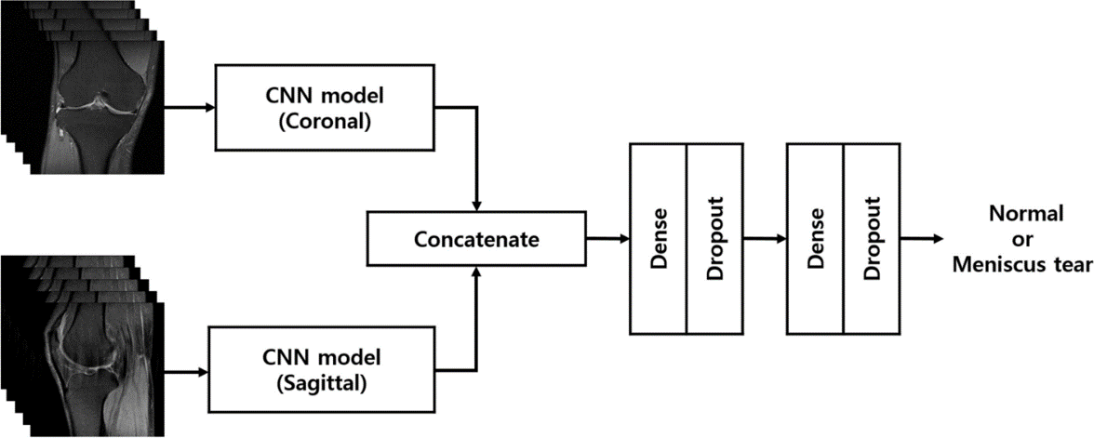

fig. 4

The second stage, activated only if a tear was detected in the first stage, utilized another AlexNet-based CNN model to classify the specific tear type using coronal MRI slices (fig. 5).

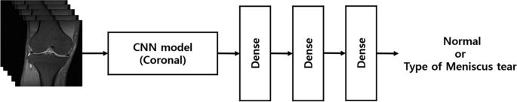

fig. 5

The results of this method deliver good detection of a tear presence in the medial meniscal, lateral meniscal, and both medial and lateral meniscal were 0.889, 0.817, and 0.924 AUCs. Furthermore, it offered additional information by classifying the specific tear type (horizontal, complex, radial, or longitudinal) with AUCs ranging from 0.6 to 0.85. However, a key drawback was the model's lower accuracy in detecting radial tears 0.6 AUC), the study acknowledges the limitations, highlighting the need for further research with less common tear types.

Another approach uses Deep convolutional neural network (DCNN) in order to determine the presence of medial and lateral tears as shown in Fritz et al.‎[7] The DCNN model begins with preprocessing the sagittal and coronal images, in order to reduce the size, to make the process time more efficient [7].

The second tire consisted of separate processing pathways for coronal and sagittal slices. Each pathway utilized convolutional layers to extract image features, followed by batch normalization and ReLU activation for improved training and non-linearity. Pooling layers were implemented for dimensionality reduction. Inception modules further enhanced feature extraction. After feature map averaging, the information from both pathways was concatenated. Final dense layers with dropout and SoftMax activation provided the probability of meniscus tear presence (fig. 6).

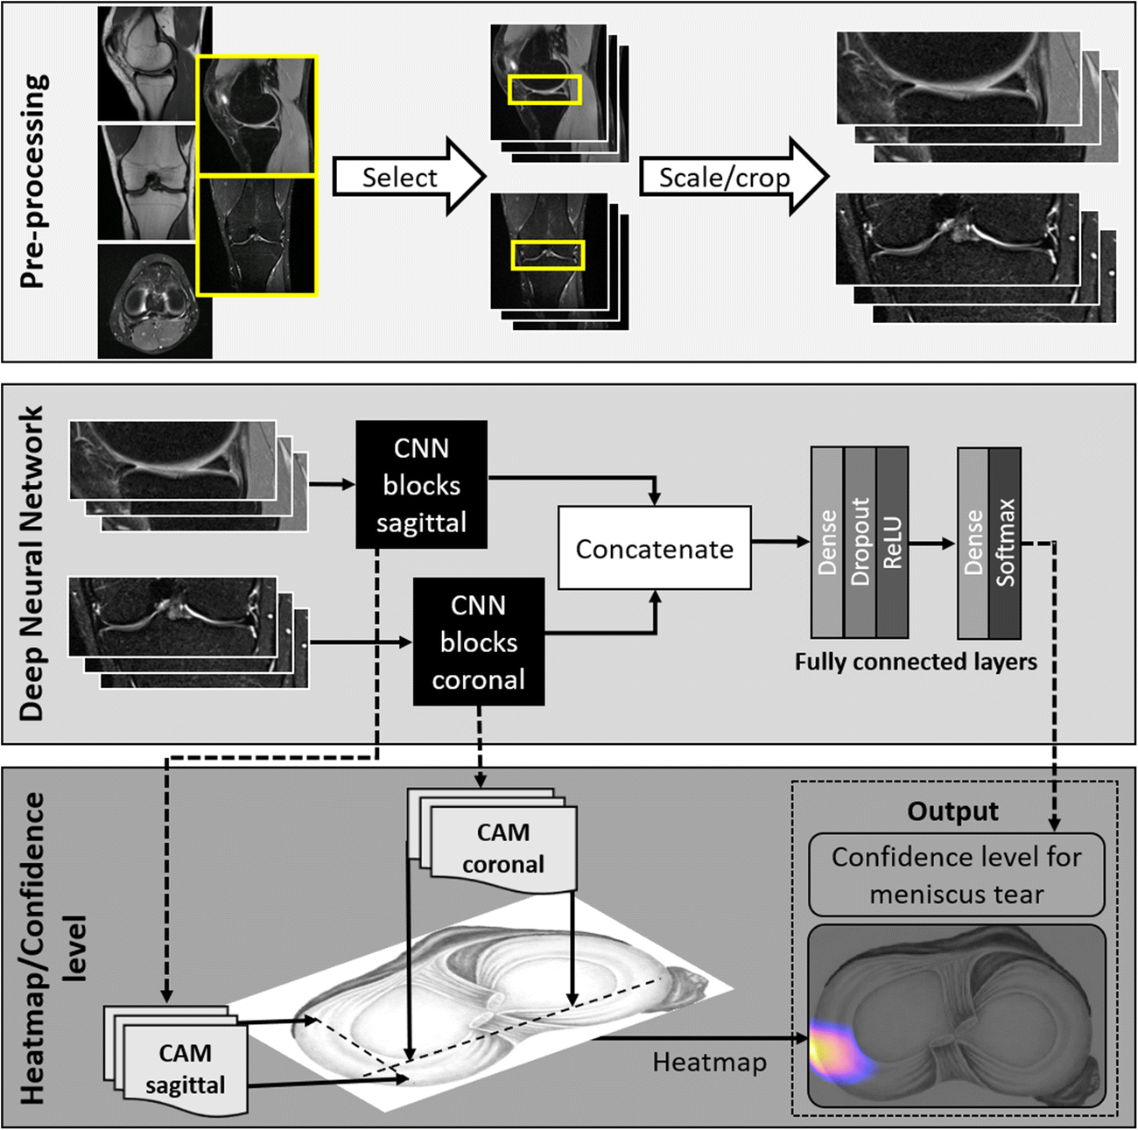

fig. 6 schematic illustration of the model, the top box represents the pre-processing of the MR images, the middle box the learning process and the last box show the heatmap that in lights the area of the tear.

The DCNN achieved good accuracy in detecting medial meniscus tears (located on the inner side of the knee), with sensitivity (ability to correctly identify a tear) around 84% and specificity (ability to correctly identify a healthy meniscus) around 88%.

For lateral meniscus tears (located on the outer side of the knee), the DCNN's sensitivity was lower at around 58%, while specificity remained around 92% [7].

Some CNN models are commonly used to simultaneously perform two tasks (identification and classification) to predict knee MR images as shown in ‎[5]‎[7]. The You Only Look Once (YOLOv4) model is a single end-to-end network that contributes to reducing the training time and the complexity of the model. Hung et al [6] ‎ established a DL model based on the YOLOv4 model that consists of a CNN backbone network, the neck, and the head. The CNN backbone network uses DarkNet53 with 24 CNN layers and 2 fully connected layers (fig. 7) for feature compression, a neck for feature mixing and combining, and a head for tear detection. Evaluation includes guided gradient weighted class activation mappings (Grad-CAMs) to visualize torn regions, show casing the model's effectiveness in accurately identifying meniscal tears in MRI images.



fig. 7 Yolov4 model architecture for the meniscus tear detection system. The proposed method included a backbone CNN (Darknet-53) for extracting feature maps.

The model's performance was comparable to or better than experienced radiologists in terms of accuracy, sensitivity, and specificity. MRI sequences were highly accurate in both coronal and sagittal planes, with better results in the coronal plane. The challenge of the sagittal plane is that the attachment of the intermuscular ligaments to the anterior horn of the meniscus may be mistaken for a tear pattern, leading to more false positives. Furthermore, small radial tears and horizontal tears are more difficult to detect on sagittal images due to volume averaging and may be better detected on coronal images ‎[6] .

A CNN approach suggests by V. Couteaux et al. (2019) ‎[9] that focused on developing a deep learning model that automatically detects and classifies tears in knee meniscus using MRI scans. The model performs preprocessing, localization of the meniscus, tear detection, and orientation classification of tears if the meniscus is found to be torn.

The pre-processing step includes three white top-hat filters on original MRI slices with square structuring elements of different sizes to the MRI images using filters that enhance the visibility of tear features (fig. 8).

The Mask R-CNN used for object detection and segmentation because it can per-form both tasks jointly, and ConvNet for tear orientation classification on the segmented meniscus region.

The model is trained to identify and separate the healthy and torn regions of both the anterior and posterior menisci within the MRI images (fig. 9**(**.To further improve the accuracy of tear orientation classification, a separate shallow convNet is used to analyze cropped images of the torn areas to classify the orientation of torn menisci as horizontal or vertical (fig. 10).

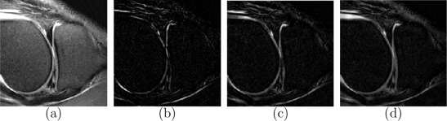

fig. 8 Pre-processing of the data used as input of the Mask R-CNN. (a) Original image. (b) 5 × 5 white top-hat. (c) 11 × 11 white top-hat. (d) 21 × 21 white top-hat

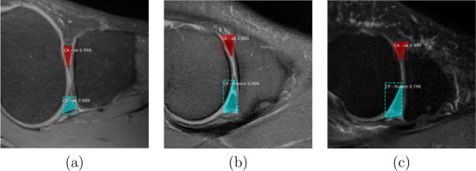

fig. 9 Output of Mask R-CNN. (a–b) Correct results. (c) Posterior meniscus incorrectly segmented and labelled as torn.



fig. 10 Patch extraction for orientation classification. (a) Extracted patch, resized to 47 × 47. (b) Local orientation map, σ= 3. (c) Local orientation map, σ = 1. (d) Black top-hat, r = 4. (e) Black top-hat, r = 8.

The model was tested on a challenge dataset and achieved impressive results, ranking first with a score of 0.906. While the model performed well in most cases, it encountered challenges with some untypical tear presentations such as several tears in the same meniscus or an extremely damaged one.

The success of this approach highlights the potential of Mask R-CNN for automating meniscus tear analysis in MRI scans. The limitations of the study include the use of a relatively small dataset and the model's struggle with some untypical cases. Future advancements could involve expanding the training data and incorporating 3D data analysis for a more comprehensive evaluation ‎[9].

# Background

CNN – Convolutional Neural Network‎[12]

General description:

A Convolutional Neural Network (CNN) is a deep learning model designed for processing grid-patterned data, particularly images, inspired by the structure of the animal visual cortex. It autonomously learns hierarchical features from simple to complex patterns. Comprising three main layers - convolution, pooling, and fully connected - CNNs extract features in the first two layers and map them to final outputs in the fully connected layer, such as classifications.

The convolution layer, pivotal in CNNs, executes operations like convolution, a specialized linear operation, across the input grid using kernels, optimizing feature extraction efficiency. This hierarchical feature extraction process enhances complexity progressively. Training involves optimizing parameters like kernels through algorithms such as backpropagation and gradient descent to minimize differences between predicted and actual outputs.

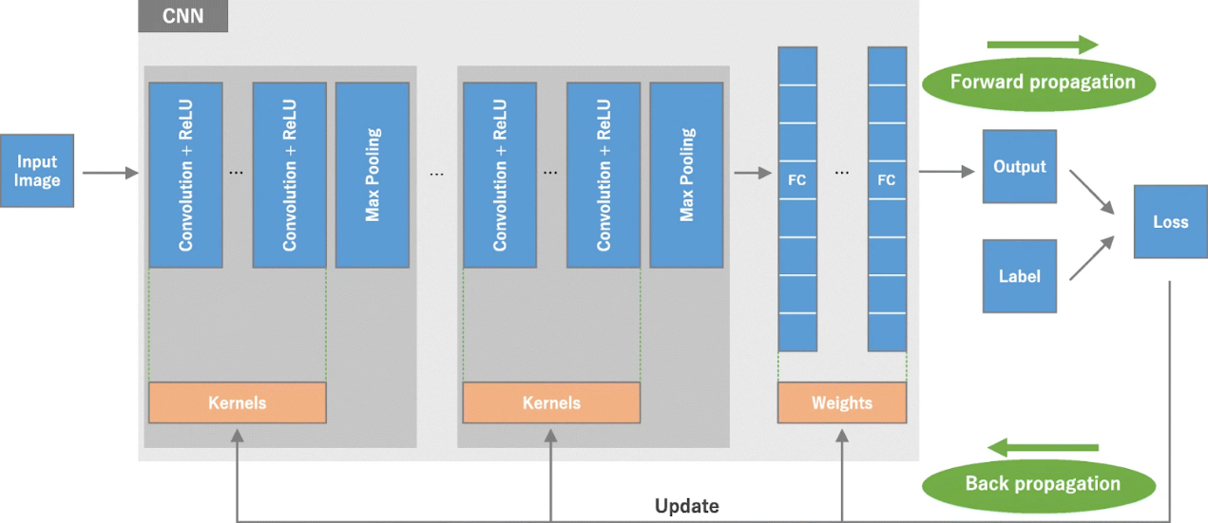

fig. 11

Convolution Layers:

A convolution layer is a major element of CNN architecture which consists combination of linear and nonlinear operations, convolutional operations and activation function.

The convolutional operation is a fundamental building block of Convolutional Neural Networks (CNNs), especially for analyzing grid-based data like images. It acts like a feature extractor that takes advantage of the spatial structure within the data.

Its procced with a small filter (kernel) with a specific size (like 3x3 or 5x5) slides across the input data one element at a time. At each location, the filter essentially multiplies its elements with corresponding elements in the input data and sums the products. This captures the presence and strength of specific features within that local area. The resulting value is placed in a new output feature map. The filter then moves on (strides) and repeats the process, building a complete feature map.

The filter size determines the size of local area that is analyzed, filter depth allows for learning different features through multiple stacked filters, stride controls how much the filter moves after each operation, and padding with zeros can be used to manage the output size and prevent information loss at the edges.

Pooling Layer:

Pooling layers delivers downsampling operation which reduces the dimensions of the feature maps, this allows reducing model complexity and computation needs. This also forces the network to focus on the most important features. Additionally, pooling layers introduce translation invariance by summarizing local information, making the network less sensitive to small shifts in the data. Unlike convolutional layers, pooling layers have no learnable parameters, but rely on hyperparameters like filter size and stride to control their behavior.

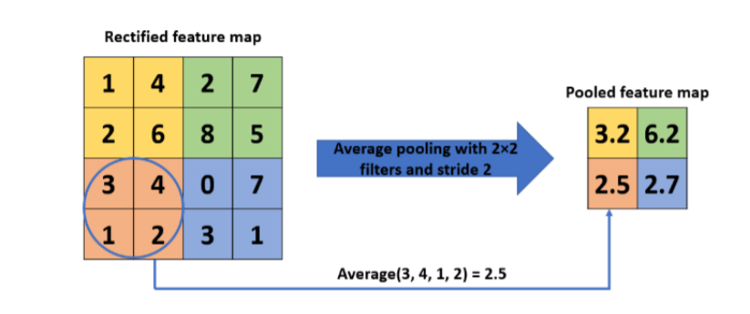

fig. 12

Activation Function:

Activation functions are essential elements in neural networks. They add non-linearity, allowing the network to learn complex patterns. These functions transform the weighted sum of inputs from previous neurons, influencing a neuron's activation level and whether it fires (sends a signal) to the next layer.

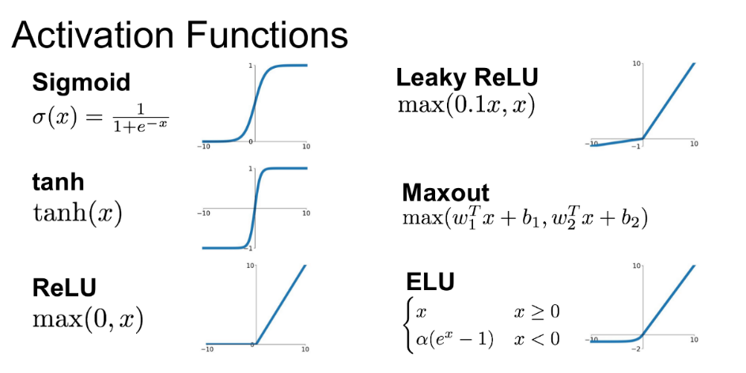

fig. 13

Fully Connected Layer:

Fully connected layers connect every neuron to all neurons in the next layer. This allows them to combine features from various parts of the image, forming a more comprehensive understanding. They're typically placed at the end of a CNN to learn complex relationships between features, crucial for tasks like object classification.

Its purpose is to take the output of the convolution/pooling process (flattened to a vector) and use them to classify the image into a label.

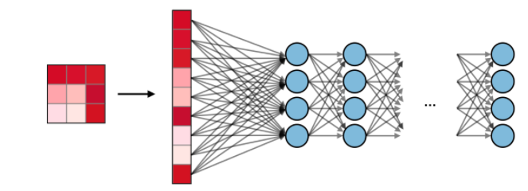

fig. 14

SoftMax:

SoftMax is a mathematical function commonly used as the activation function in the output layer of a neural network for multi-class classification tasks.

The SoftMax function takes a vector of real numbers as input, often representing the network's unnormalized preferences for each class. It then applies a mathematical transformation to ensure the output values range between 0 and 1.

The sum of all the output values after SoftMax is always equal to 1. This allows interpretation of the outputs as probabilities, indicating the likelihood of the input belonging to each respective class.

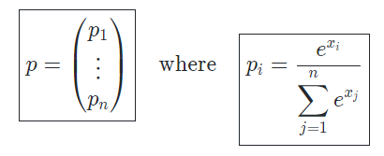

fig. 15 SoftMax definition

# Expected Achievements

We expect to build a deep learning model that will be able to correctly classify whether a person has a meniscal tear and its type by inserting an MRI scan, our CNN model will be based on DenseNets, and will be trained with MRI scans of patients with and without different types of meniscal tears

A DenseNet-based deep learning model for meniscal tear classification from MRI images holds immense promise for orthopedic medicine. This approach has the potential to significantly improve diagnostic accuracy and efficiency, ultimately leading to better patient outcomes.

DenseNets excel at image recognition. Our model, aiming for an accuracy range of 0.86-0.97, could surpass human interpretation limitations, leading to more definitive diagnoses and streamlined treatment plans.

The model's objective analysis minimizes inter-observer variability among radiologists, promoting consistent diagnoses. Additionally, rapid MRI analysis significantly improves workflow efficiency, allowing for quicker treatment decisions.

Faster and more accurate diagnoses enable earlier intervention, crucial for selecting appropriate treatments and improving patient outcomes.

This classification task is challenging due to different types of meniscal tears, several locations and various levels of the tear severity.

# Research

## CNN Architecture Research

### Densely Connected Convolutional Networks (DenseNets)‎[11]

As CNNs become deeper, they face challenges related to information and gradient flow. Long chains of layers can lead to vanishing gradients or information loss, affecting the network's ability to learn effectively. Dense Convolutional Network (DenseNet) is a type of deep learning architecture specifically designed to address some challenges faced CNNs. The key feature of DenseNet is its dense connectivity pattern, where each layer is connected to every other layer with the same feature-map size in a feed-forward manner within a dense block, there are L(L+1)/2 connections in an L-layer network. This dense connectivity enables feature reuse and facilitates information flow throughout the network.

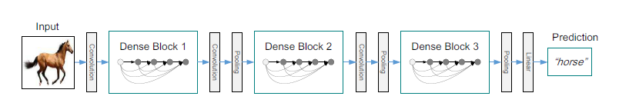

fig. 16 A deep DenseNet with three dense blocks. The layers between two adjacent blocks are referred to as transition layers and change feature-map sizes via convolution and pooling

**DenseNet Architecture:**

Dense Block:

A dense block assembled of *n*dense layers, and the concept of dense connections has been portrayed in dense blocks giving each layer access to the input feature map and to the gradient loss function of all of its preceding.

These dense layers are connected using a dense circuitry such that each dense layer receives feature maps from all preceding layers and passes it’s feature maps to all subsequent layers, while preserving the features map scales the same.

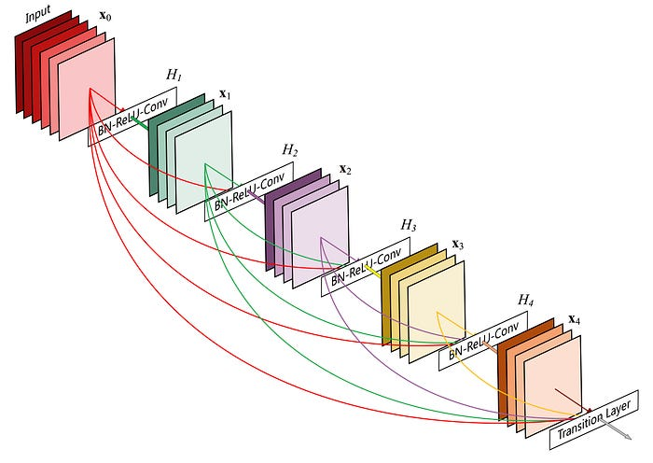

fig. 17 A 5-layer dense block with a growth rate of k = 4.Each layer takes all preceding feature-maps as input.

The output of the dense block has a grow rate (k) which is the number of the output channels by a dense layer that concatenated and fed as the input to the next dense layer.

At the end of each dense block, the number of feature-maps accumulates to a value of — *input features + (number of dense layers x growth rate).*

Composite function:

In some DenseNet architectures each conv layer includes the corresponding operation of BatchNorm→ ReLU→ Conv.

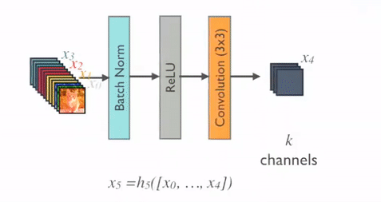

fig. 18

Transition Layer: (pooling layer)

Transition layers are used to downsample feature maps and adjust the number of channels between 2 dense blocks. They typically include a combination of *1x1* convolutions for dimensionality reduction and *2X2* average pooling for downsampling.

Bottleneck layer:

DenseNet often uses bottleneck layers to reduce computational complexity. These layers consist of *1x1* convolutions that reduce the number of input channels before applying *3x3* convolutions. This helps in reducing the number of parameters and computational cost without sacrificing the learning capability.

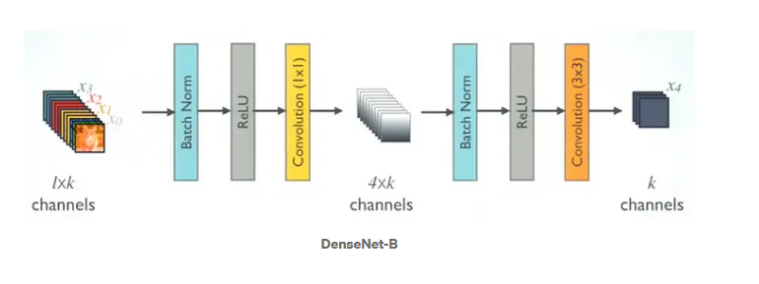

fig. 19

Compression:

Compression is used to further improve model compactness by reducing the number of feature maps at transition layers. If a dense block contains m feature maps, the following transition layer generates $\left\lfloor θm\right\rfloor$ output feature maps, where $0<θ<1$ is the compression factor. A compression factor of $θ=1$ means the number of feature maps remains unchanged across transition layers.

## Hyper Parameters

**Researched hyperparameters** in our model are:

* Learning rate {$5⋅{10}^{-3}$, $5⋅{10}^{-4},5⋅{10}^{-5}$}
* Epochs {50, 100}
* Batch size {16, 32, 64}
* Batch normalization – with/ without

Evaluation metric

Some evaluation metrics, including accuracy, precision, and recall, were adopted to compare the performances of our model and compare the performances of different methods.

* TP=True positive, the model predicted that there was a tear in the meniscus, and the MRI scan was correctly classified.
* TN = True Negative, the model prediction was that there was no tear in the meniscus and the MRI scan was correctly classified.
* FP = False Positive, the model predicted there was a tear in the meniscus and the MRI scan was misclassified.
* FN = False Negative, the model prediction was that there was no tear in the meniscus and the MRI scan was misclassified.
* Accuracy = The relative share of the positive answer in all our parameters. The result will be between zero and one, with one being the best level of accuracy and zero being the worst.
$$Accuracy=\frac{TP + TN }{TP + TN + FP + FN}$$

* Precision= MRI scans correctly classified as meniscus tears out of all those classified as meniscus tears
$$Precision=\frac{TP}{TP+FP}$$

* Recall= Out of all those with a meniscus tear, the number of MRI scans correctly classified as a meniscus tear

$$Recall=\frac{TP}{TP+FN}$$

# Product

## Sequence diagram

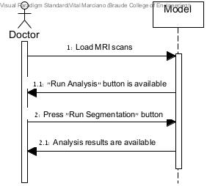

fig. 20

## GUI

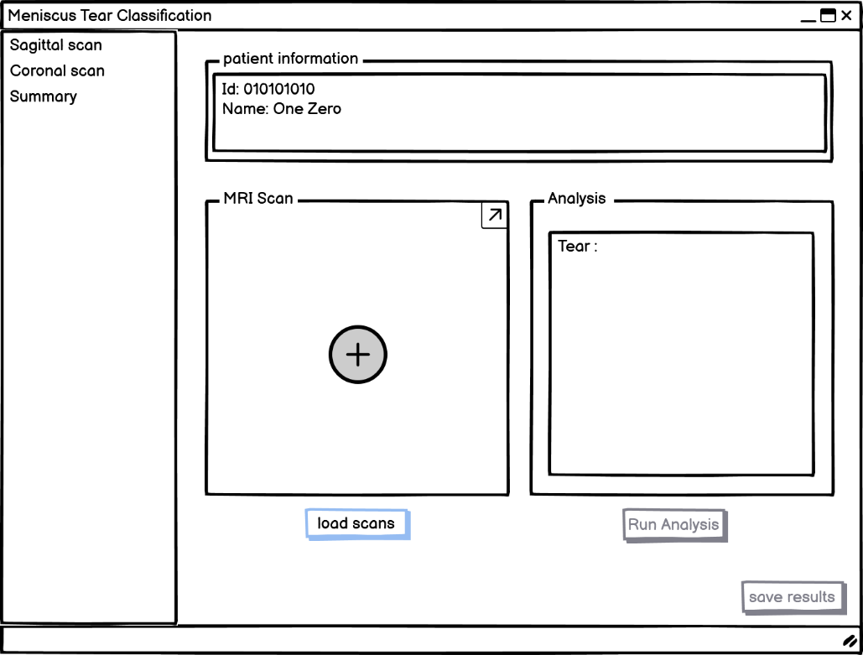

fig. 21 GUI pre loading MRI scans

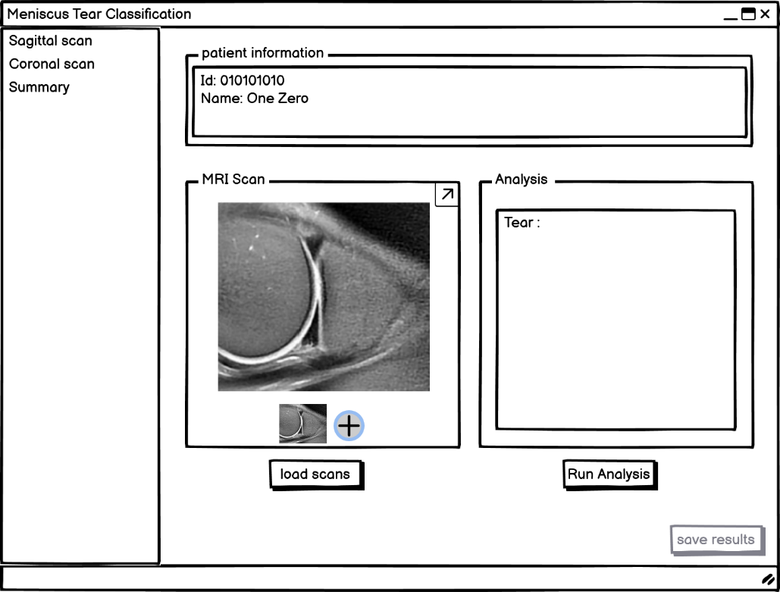

fig. 22 GUI loading MRI scans

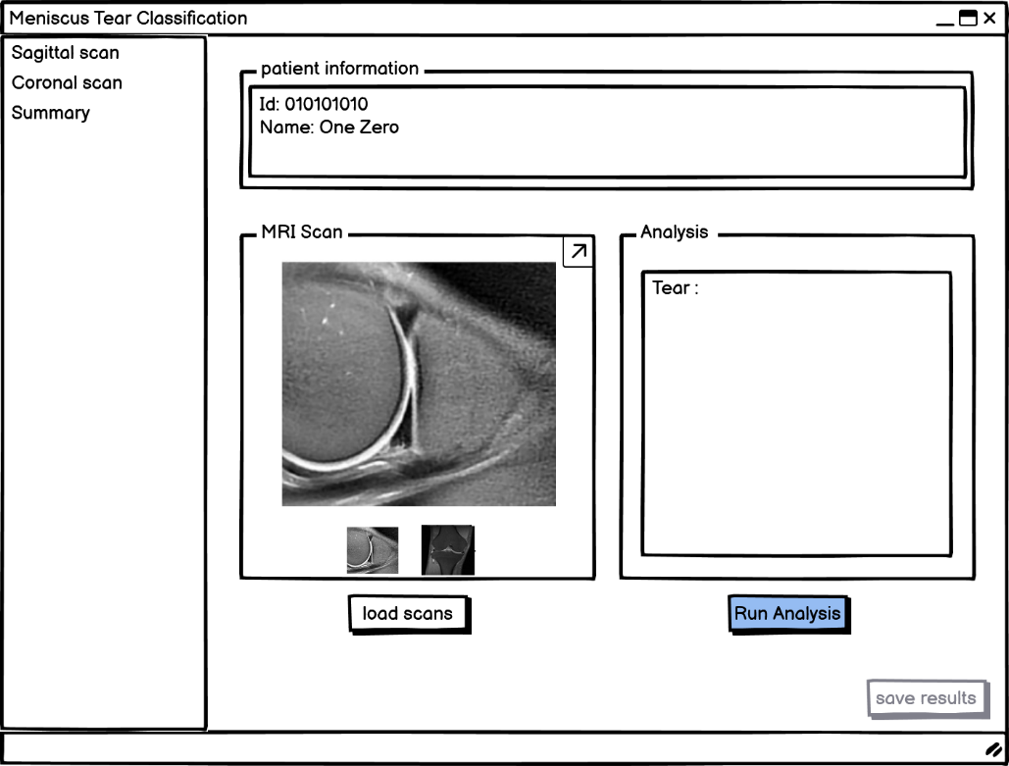

fig. 23 GUI loading MRI scans and run analysis

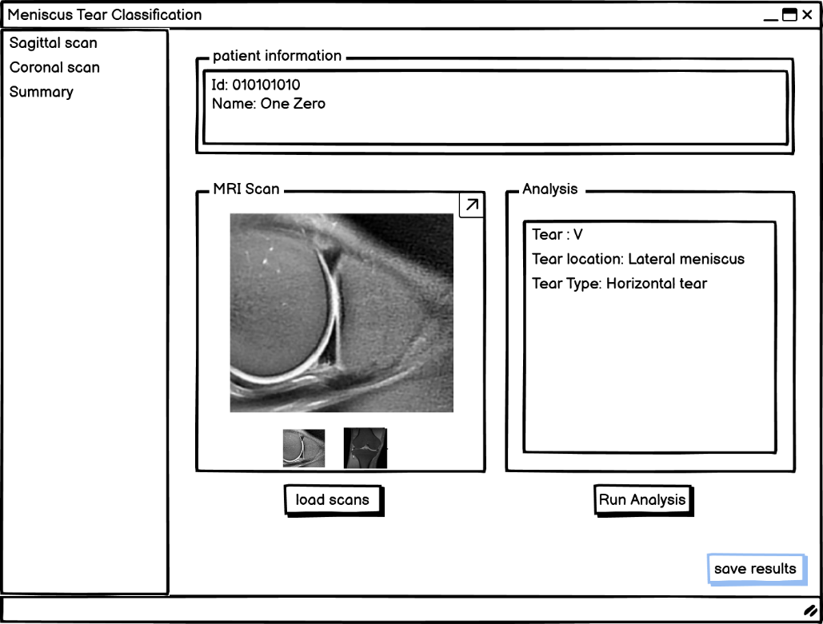

fig. 24 GUI save the predictions results

# Evaluation/Verification Plan

|  |  |  |
| --- | --- | --- |
| **Case** | **Test Case** | **Expected Result** |
| 1 | Press "load scans" button | An image is loaded on MRI scans box. |
| 2 | Press "Run Analysis" button | The classification results will appear in the analysis box |
| 3 | Press "save results" button | A document with the classification results is saved in the file system |
| 4 | Press "+" button | An image is loaded on MRI scans box |
| 5 | Press "Run Analysis" button without loading an image | Display error message: "Please load image" |

Table 1 Optional Test Cases

# References

1. Andrews, S. H., Adesida, A. B., Abusara, Z., & Shrive, N. G. (2017). Current concepts on structure–function relationships in the menisci. Connective tissue research, 58(3-4), 271-281.‏
2. Smoak, J. B., Matthews, J. R., Vinod, A. V., Kluczynski, M. A., & Bisson, L. J. (2020). An up-to-date review of the meniscus literature: a systematic summary of systematic reviews and meta-analyses. Orthopaedic journal of sports medicine, 8(9), 2325967120950306.‏
3. Ghidotti, A', Regazzoni, D', & Weiss Cohen, M'. (2023). The Effect of Meniscal Tears on Knee Biomechanics. *The Effect of Meniscal Tears on Knee Biomechanics*, 1-5.
4. Fox, A. J., Bedi, A., & Rodeo, S. A. (2012). The basic science of human knee menisci: structure, composition, and function. Sports health, 4(4), 340-351.‏
5. Shin, H., Choi, G. S., Shon, O. J., Kim, G. B., & Chang, M. C. (2022). Development of convolutional neural network model for diagnosing meniscus tear using magnetic resonance image. BMC Musculoskeletal Disorders, 23(1), 510.‏
6. Hung, T. N. K., Vy, V. P. T., Tri, N. M., Hoang, L. N., Tuan, L. V., Ho, Q. T., ... & Kang, J. H. (2023). Automatic detection of meniscus tears using backbone convolutional neural networks on knee MRI. Journal of Magnetic Resonance Imaging, 57(3), 740-749.‏
7. Fritz, B., Marbach, G., Civardi, F., Fucentese, S. F., & Pfirrmann, C. W. (2020). Deep convolutional neural network-based detection of meniscus tears: comparison with radiologists and surgery as standard of reference. Skeletal radiology, 49, 1207-1217.‏
8. Nacey, N.C., Geeslin, M.G., Miller, G.W. and Pierce, J.L., 2017. Magnetic resonance imaging of the knee: An overview and update of conventional and state of the art imaging. Journal of Magnetic Resonance Imaging, 45(5), pp.1257-1275.
9. Couteaux, V., Si-Mohamed, S., Nempont, O., Lefevre, T., Popoff, A., Pizaine, G., ... & Boussel, L. (2019). Automatic knee meniscus tear detection and orientation classification with Mask-RCNN. *Diagnostic and interventional imaging*, *100*(4), 235-242.‏
10. Ghidotti, A., Cattaneo, A., Vitali, A., Regazzoni, D., & Rizzi, C. (2023). ACL Morsky: Semi-automatic Tool for Assessing the Risk of Developing an Anterior Cruciate Ligament Injury. *COMPUTER-AIDED DESIGN AND APPLICATIONS*, *20*(4), 736-748.‏
11. Huang, G., Liu, Z., Van Der Maaten, L., & Weinberger, K. Q. (2017). Densely connected convolutional networks. In Proceedings of the IEEE conference on computer vision and pattern recognition (pp. 4700-4708).‏
12. Rikiya Yamashita, Mizuho Nishio, Richard Kinh Gian Do and Kaori Togashi, “Convolutional neural networks: an overview and application in radiology”, Insights into Imaging volume 9, pages 611–629 (2018).